**St. Francis Institute of Technology**

**PYTHON LAB: PRACTICAL EXAM**

1. Write another program that prompts for a list of numbers as above and at the end prints out both the maximum and minimum of the numbers instead of the

average.

**Code:**

# PYTHON PROGRAM

'''

Write another program that prompts for a list of

numbers as above and at the end prints out both the

maximum and minimum of the numbers instead of the

average.

'''

# create an empty list

l1 = []

a = int(input('Total number of elements in the list: '))

for i in range(0,a):

e = float(input('Enter to the list: '))

# append to the list

l1.append(e)

print(f'The List is {l1}')

# built-in function to find max no in the list

print(f'Max number in the List is {max(l1)}')

# built-in function to find min no in the list

print(f'Min number in the List is {min(l1)}')

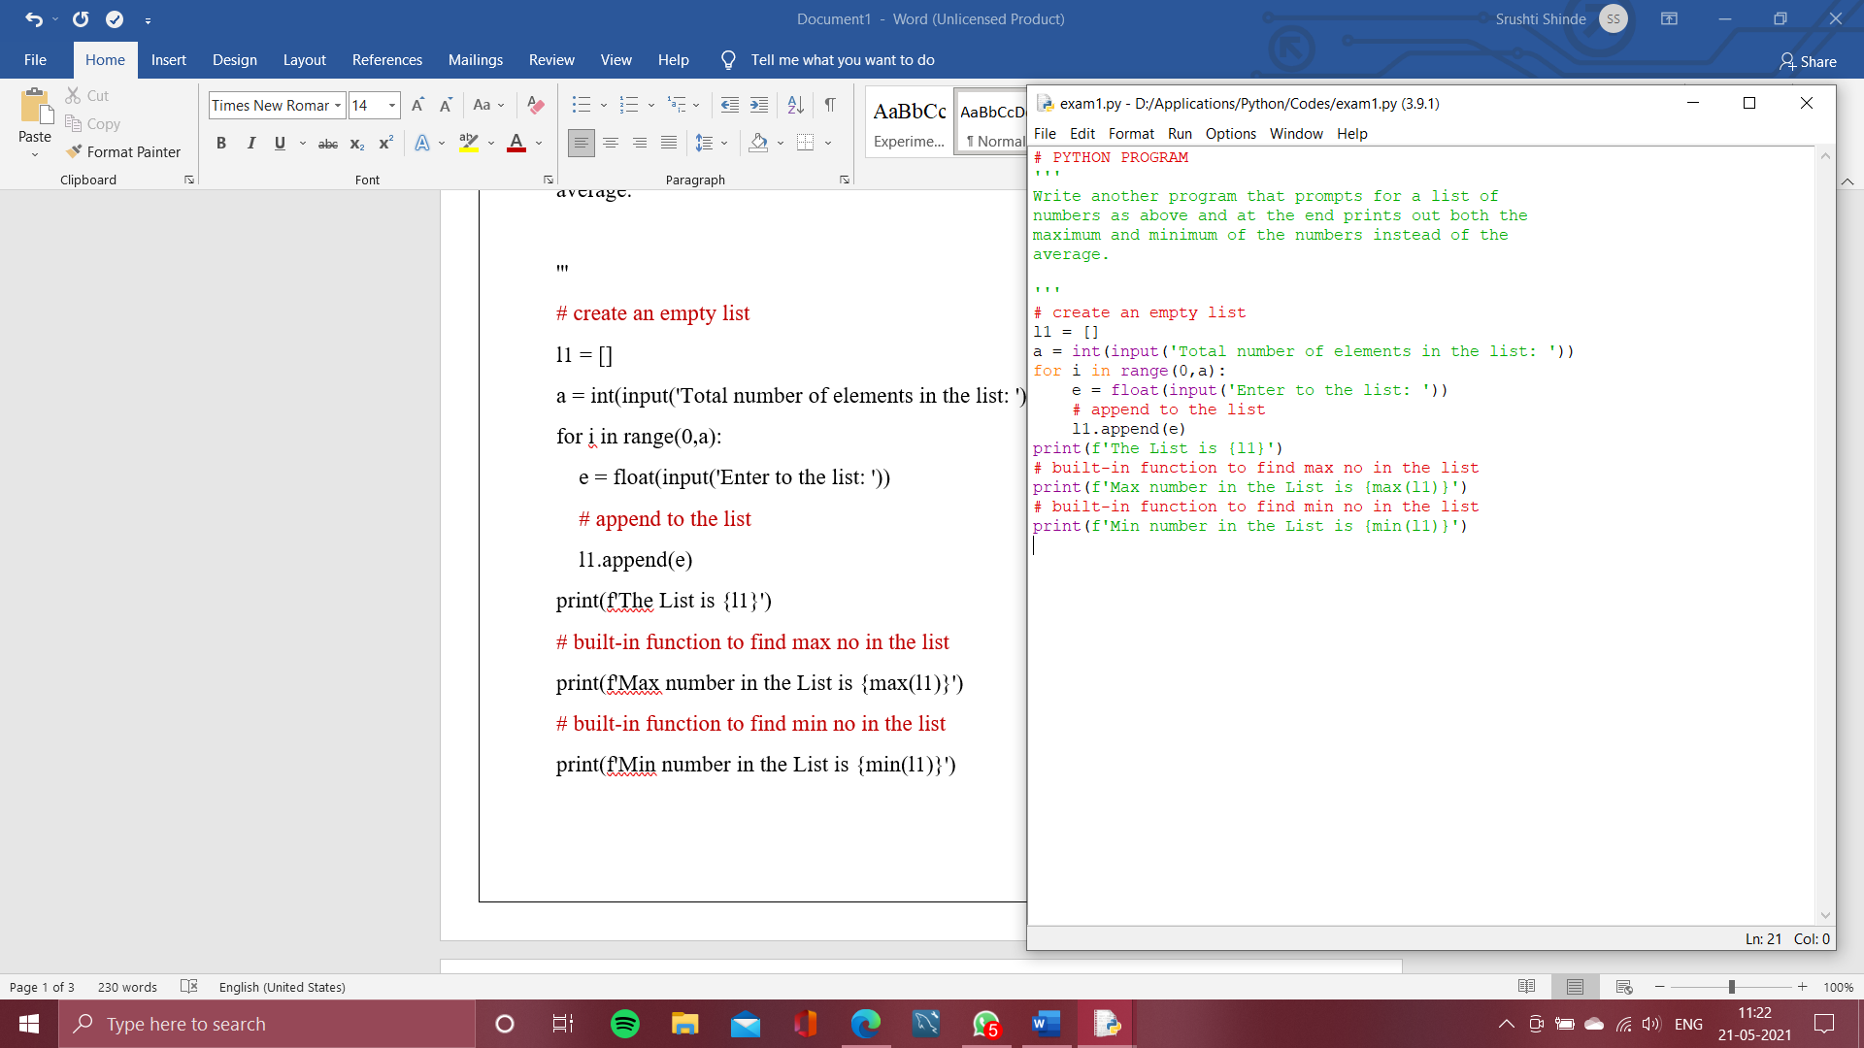

**Flowchart:**

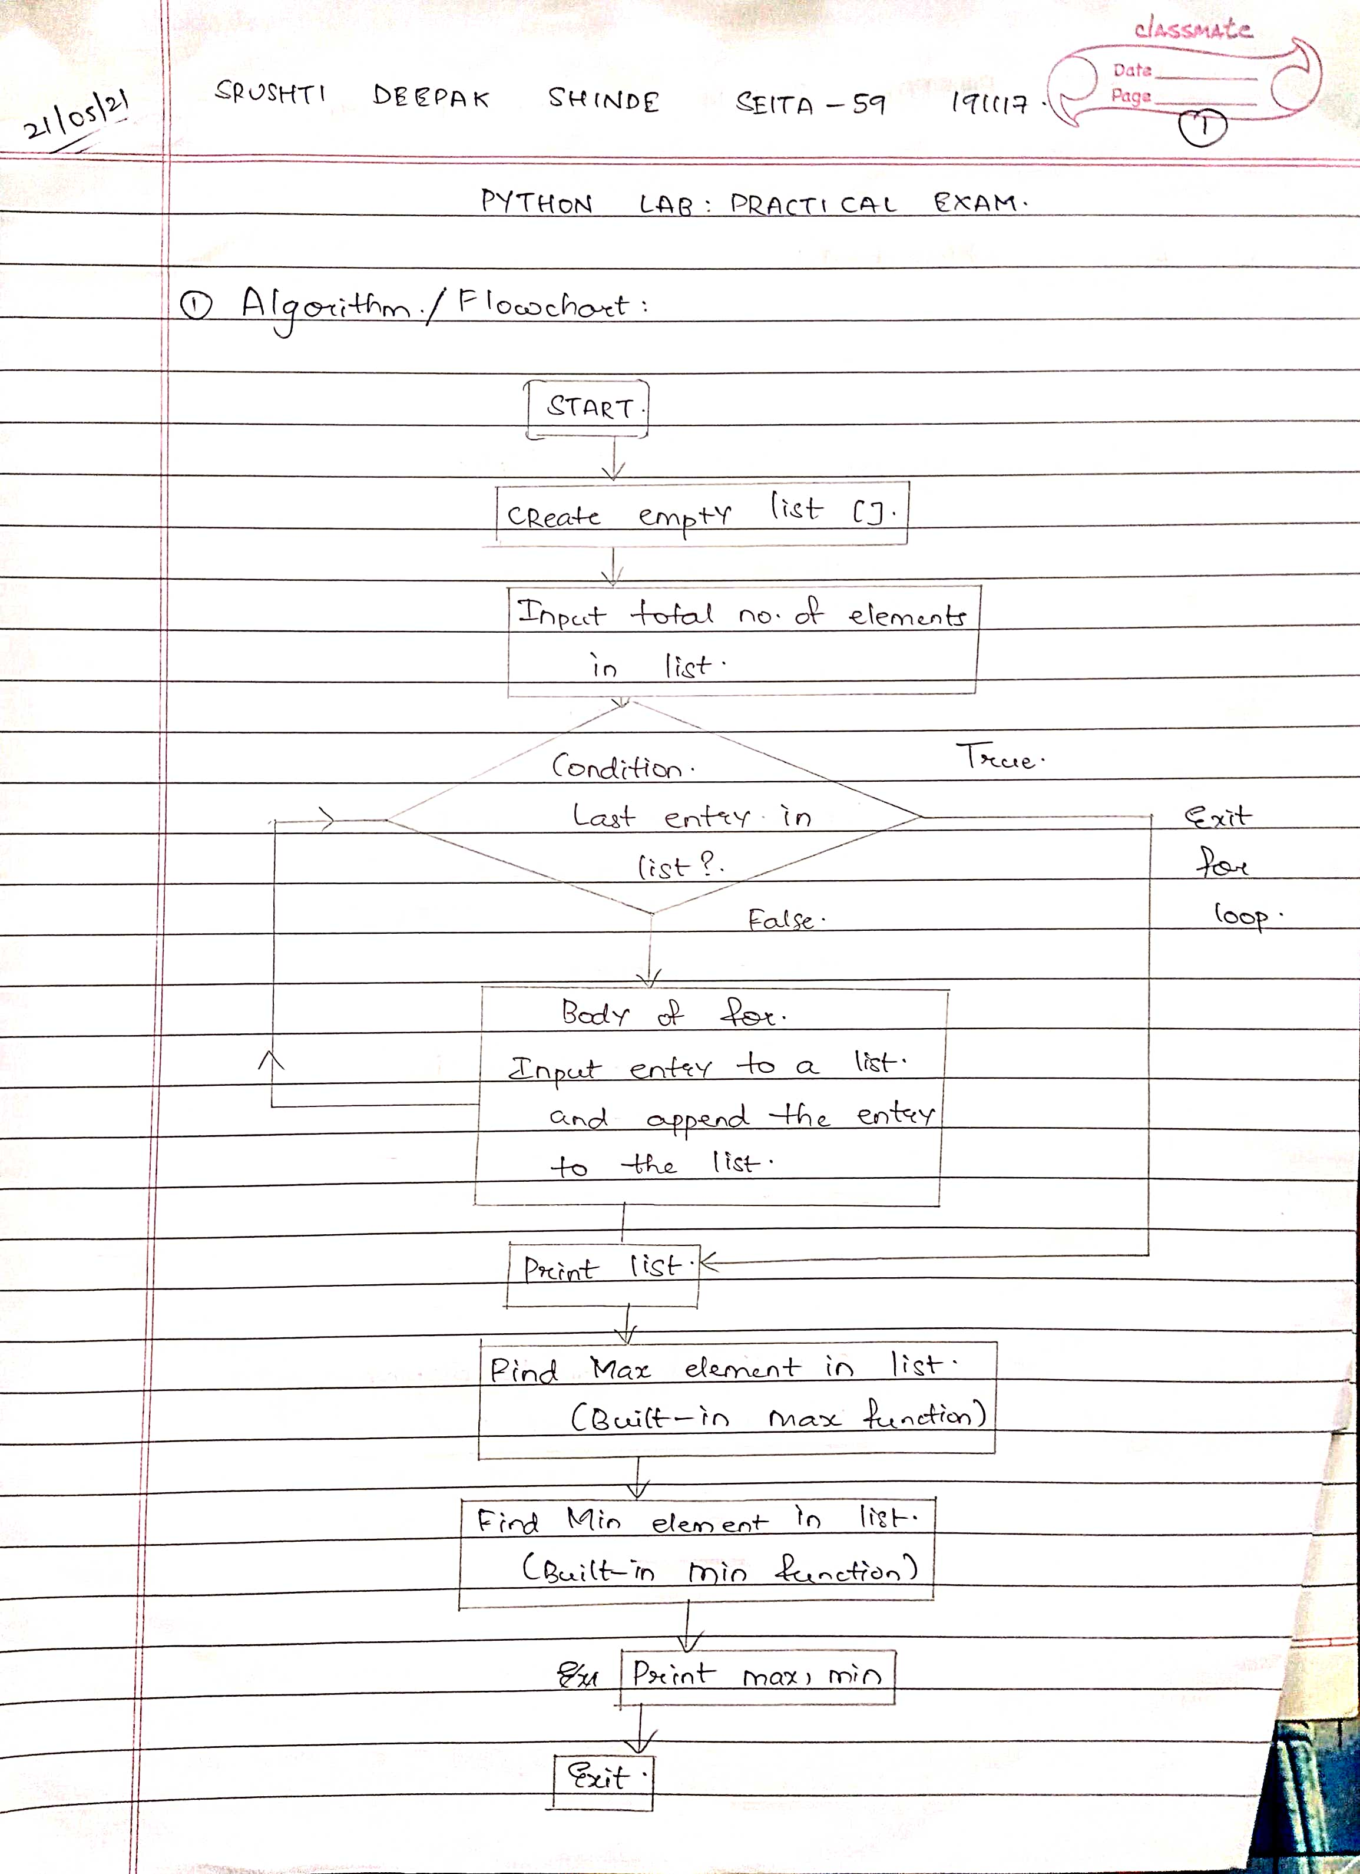

**Output:**

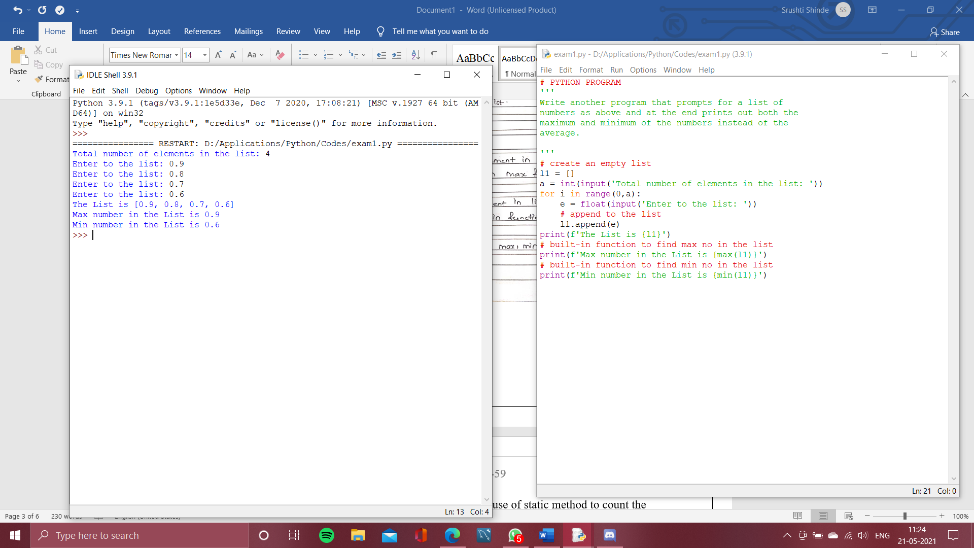

2. Write a Python program to demonstrate use of static method to count the number of instances created.

**Code:**

# PYTHON PROGRAM

'''

Write a Python program to demonstrate use of static

method to count the number of instances created.

'''

class Static_Method:

s = 0

def __init__(self):

Static_Method.s = Static_Method.s+1

@staticmethod

def no_instances():

print(f'In class Static_Method,')

print(f'{Static_Method.s} instances are created')

inst1 = Static_Method()

inst = Static_Method()

inst2 = Static_Method()

inst3 = Static_Method()

inst4 = Static_Method()

Static_Method.no_instances()

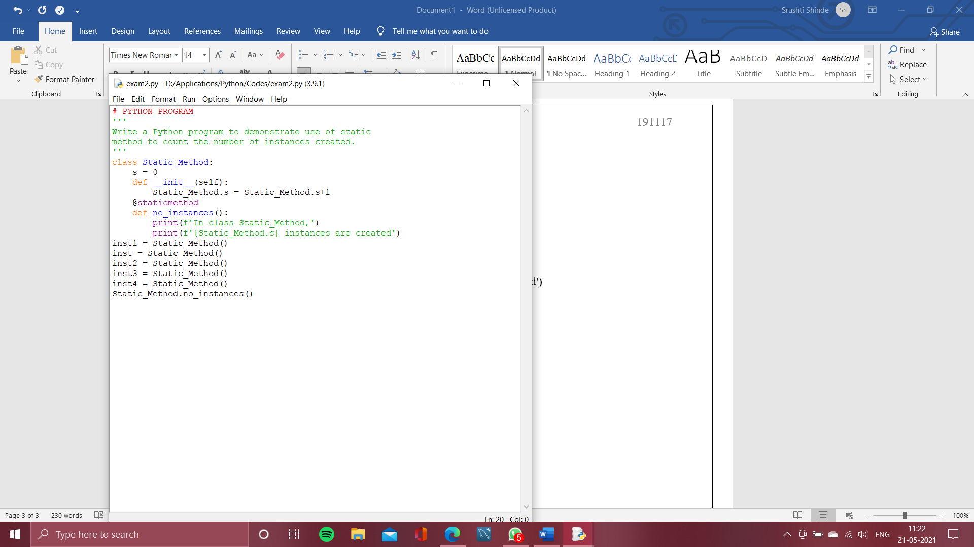

**Flowchart:**

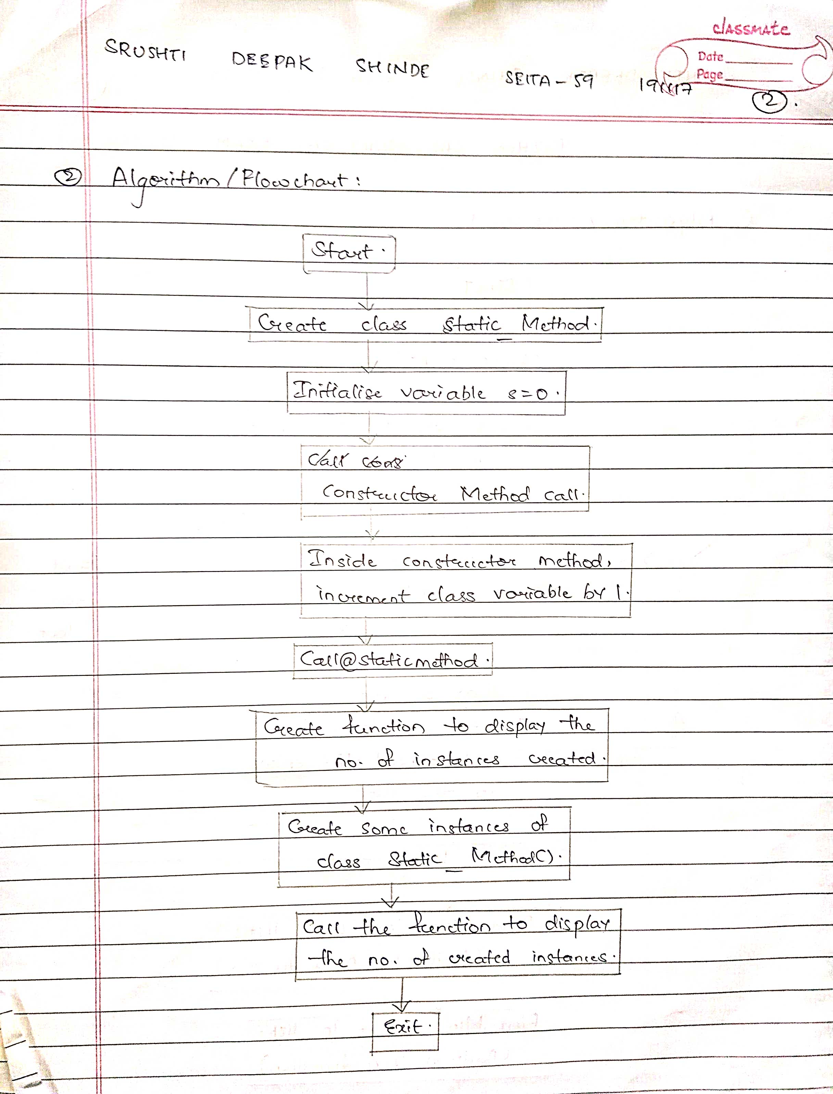

**Output:**

